Lab#06
Implementation of math class with various
methods in java
Objective
To get familiarity with the math class with various methods in java.
Lab Goals
To provide working insight into the usage of math class in java programming:
a. Demonstrate the implementation of math class.
b. Understand the purpose and usage of the Math class in Java.
c. Learn about the various mathematical functions and constants provided by the Math class.

Math Function
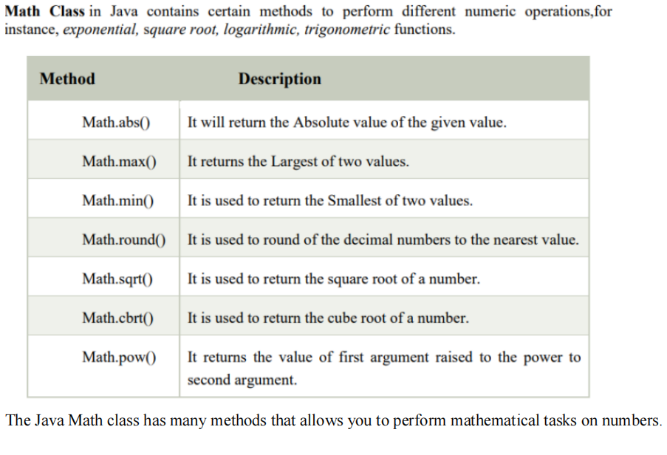

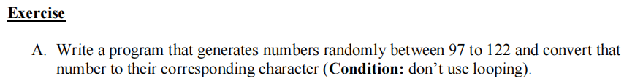
Program:
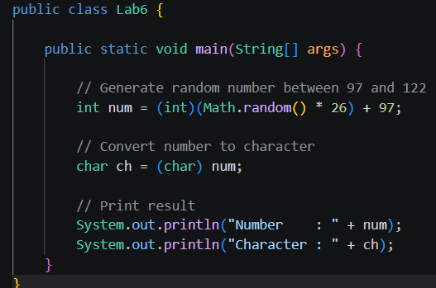
Output:
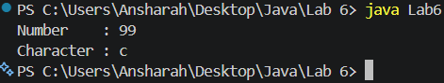
Program:
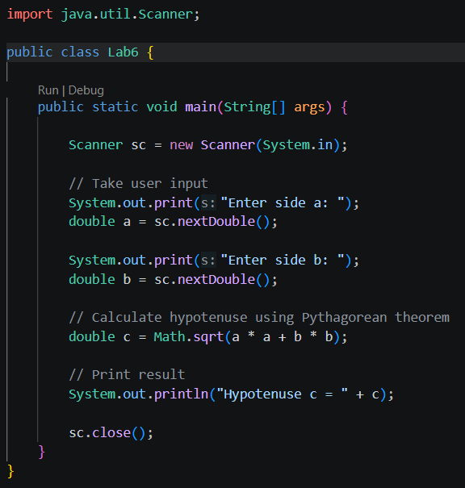

Output:
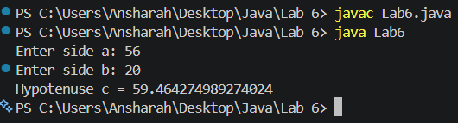
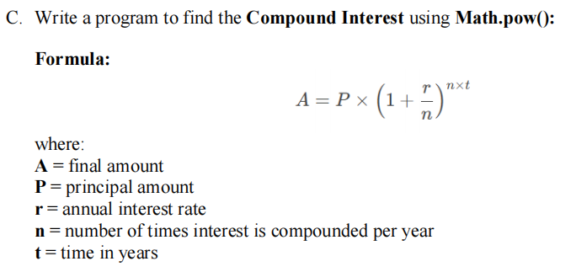
Program:
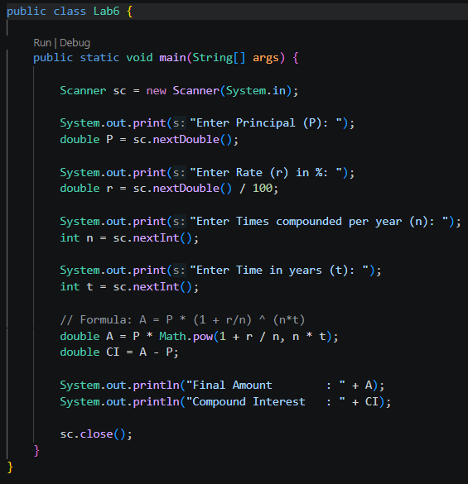

Output:
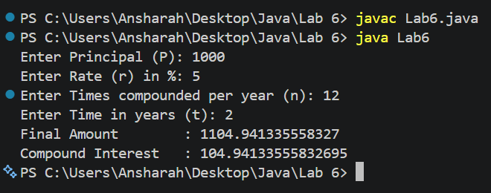
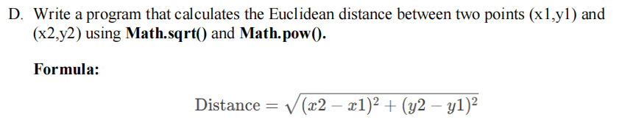
Program:
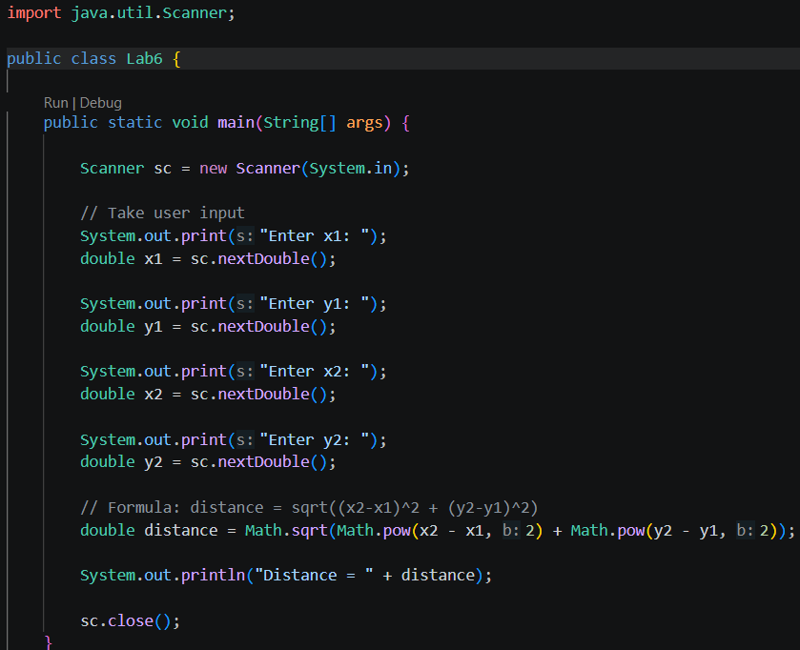
Output:
